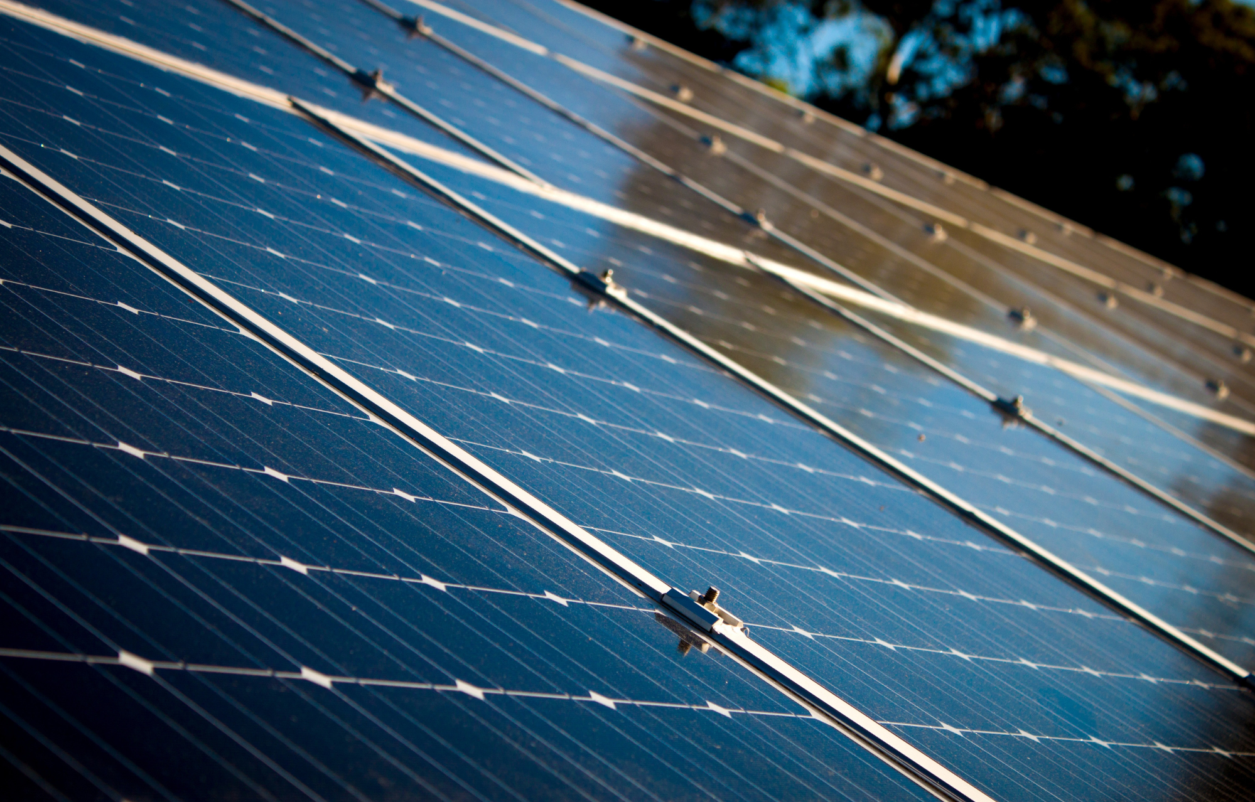

Team

222

Index

A

1. Introduction

1.1 India’s electricity sector

India with its population of ~1.4 billion people and gross domestic product of USD 3.05 trillion is the third largest producer of electricity in the world with the national grid having an installed capacity of 395 GW. The electricity consumption of India has grown steadily at a CAGR of 6.44% between 2002-2021 as can be seen in Figure 1 below:

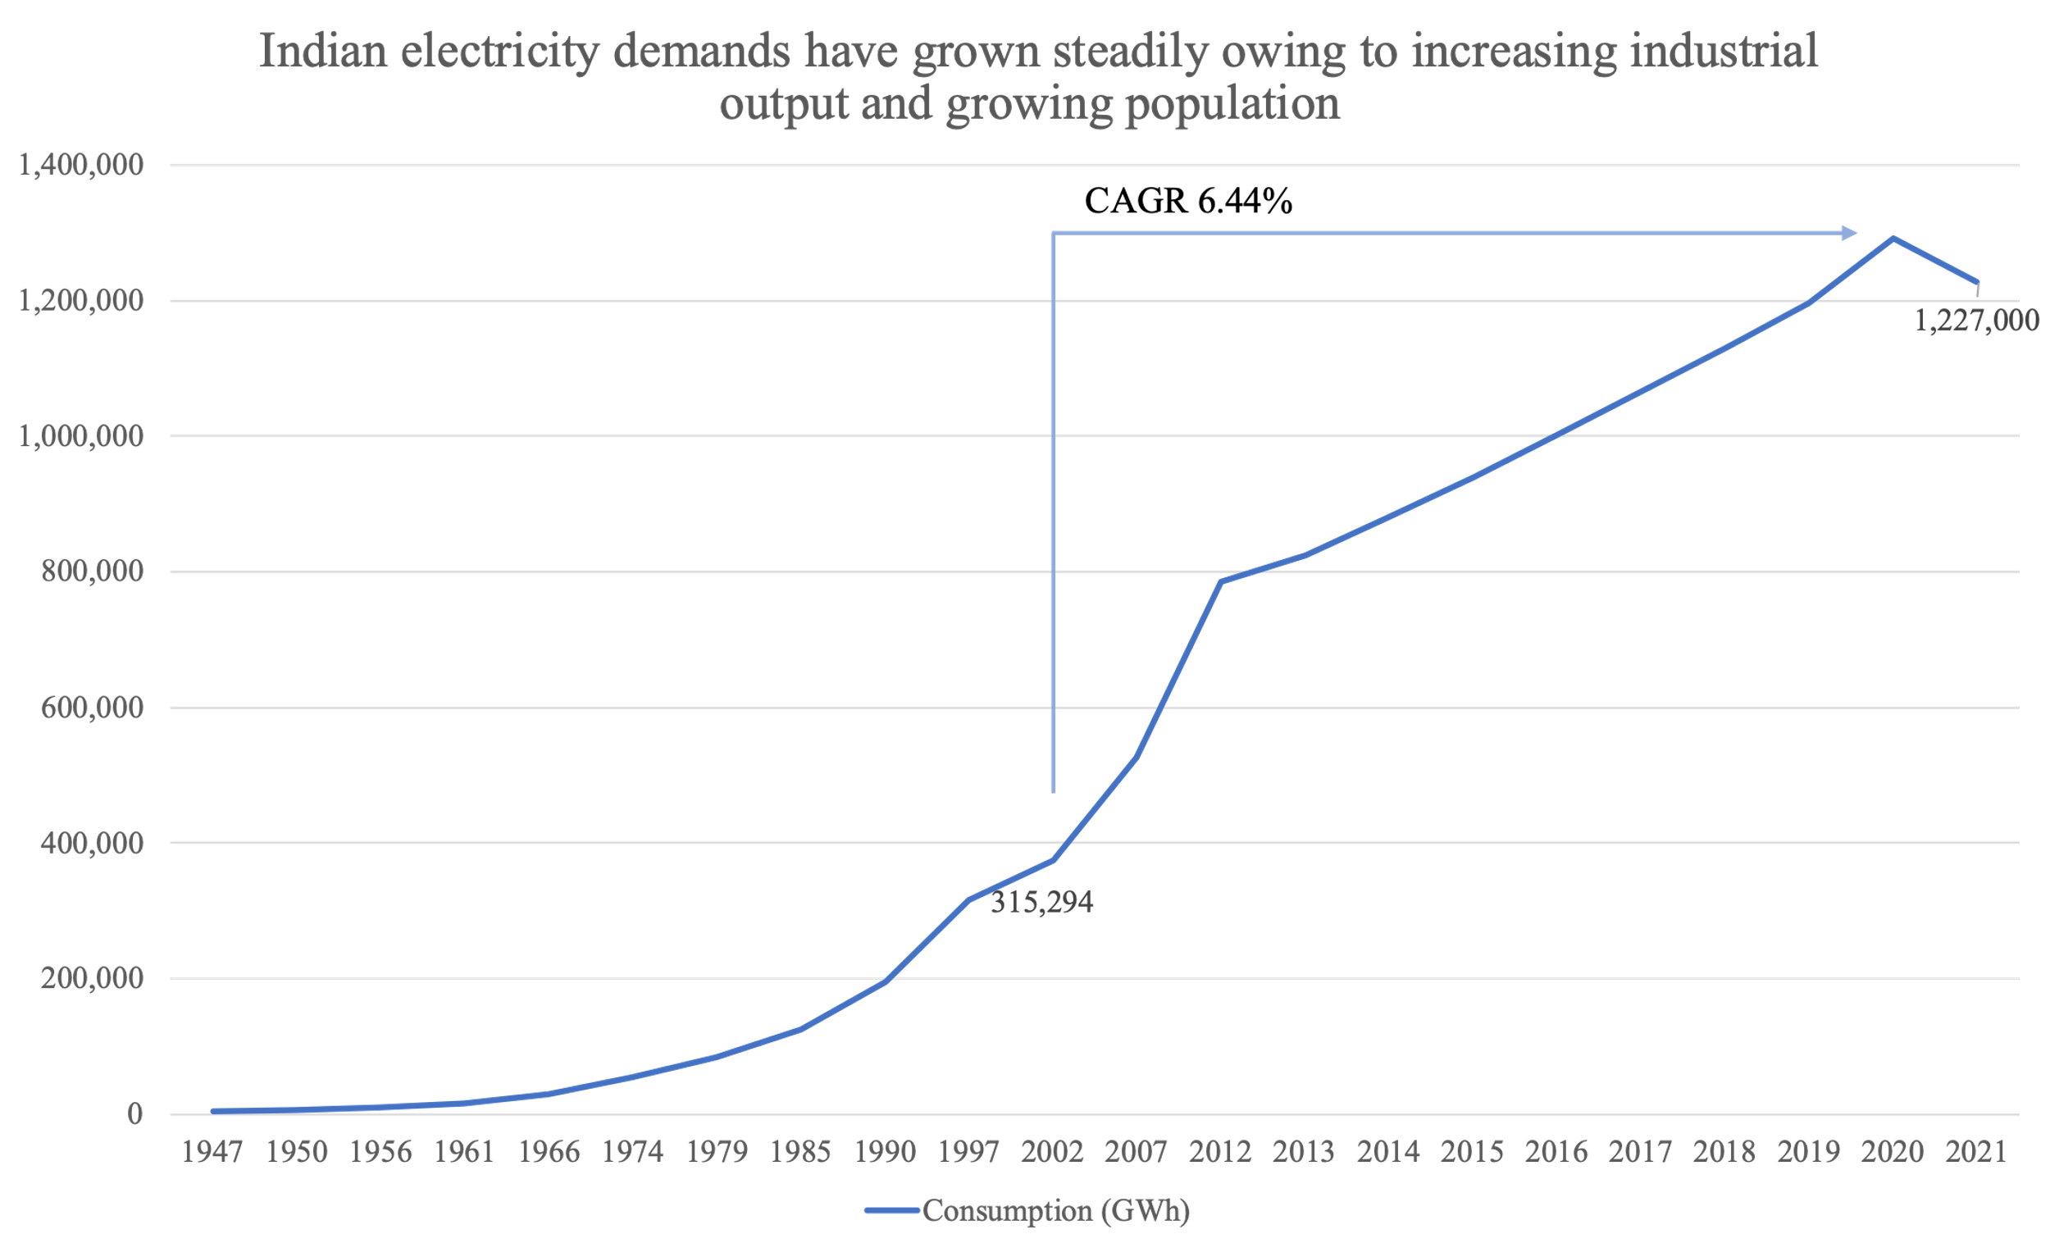

Figure 1: Indian Annual Electricity Consumption in GWh

This demand is catered to through a mix of renewable and non-renewable energy sources as show in Figure 2 below. Recently, installed non-fossil fuel electricity capacity surpassed 40% and is a major indication of the measures being undertaken to transition India’s energy infrastructure to renewable sources. Solar and wind energy are expected to be the main drivers in the transition to renewable energy sources for India.

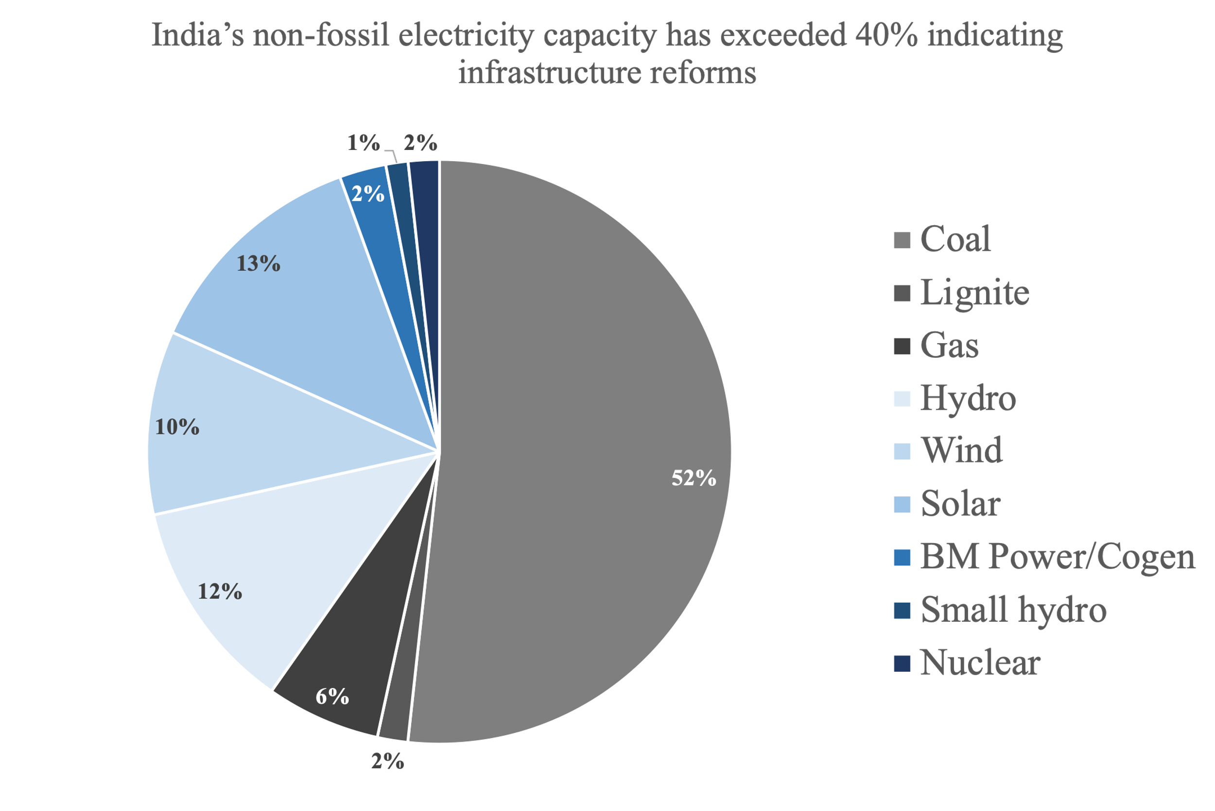

Figure 2: Source-wise installed electricity generation capacity (MW)

These installed capacities for electricity generation have helped in ensuring that India’s electricity generation keeps pace with its demands having brought down the peak power deficit from 16.6% in financial year (FY) 2008 down to 0.4% in FY 2021. Figure 3 shows the breakup of electricity generation by source on an annual basis. We observe that in recent years, wind energy (post 2014) and solar energy (post 2017) have seen major boosts while simultaneously, electricity generation from expensive coal-fuelled plants has been on the decline since 2018. This is a welcome push towards transitioning dependence to renewable energy sources. These pushes have been fuelled by favourable policy measures and increased interest in investment from the private sector.



Figure 3: Source-wise Indian Annual Electricity Generation in TWh

1.2 Necessity of boosting renewable energy sources

The costs of generating electricity from renewable sources have been constantly declining with research on generation technologies improving efficiencies and bringing down material and manufacturing costs. With the setting up of large scale manufacturing facilities, economies of scale are being observed leading to greater manufacturing efficiencies, leading to cost reductions. Considering Levelized Cost of Electricity (LCOE) data from a study conducted by the International Renewable Energy Agency (IRENA), the **cost of electricity decreases by 46%** for India on average if we completely switch to renewable energy sources according to their generation potential in the country, ignoring for additional energy storage set-up and running costs. These cost reduction levels were unimaginable even as recently as 2010.

The Indian government has committed 500 GW of renewable energy (RE) power capacity by 2030 making the contribution of RE to total installed power capacity at 50%. Out of this, 152 GW of RE power capacity has already been installed with ~63 GW of RE power capacity under construction. It is targeted that out of the total 500 GW RE capacity in 2030, 450 GW will be from solar and wind projects and 70-100 GW from hydro projects. This is in line with the percentages of source-wise RE potentials across the country as shown below.



Figure 4: Total Generation Potential for RE source across India (MW)

As we can see from the above table, wind and solar projects hold the key for transitioning the energy infrastructure of the country to renewable sources of generation.

2. Solar Policy

2.1 Overview

The **National Solar Mission (NSM)** visions India as a global leader in solar energy by creating the policy conditions for solar technology diffusion across the country as quickly as possible. The Mission targets installing 100 GW grid-connected solar power plants by the year 2022. Moreover, it is targeted to install solar capacity of ~220 GW by 2030. The integration should gradually be done from transmission level by the utility scale companies to the distribution level at the residential scale. Dividing the time scale into three frames, the transition from utility to distribution scale is possible.

Figure 5: Power Grid of India integration plan

2.2 Trickle Down Solar Policy

|  |  |  |
| --- | --- | --- |
| **Short term** | **Mid term** | **Long term** |
| Utility scale companies boosting up the adoption percentage of the solar integration by setting them up at transmission level | Utility scale companies would set up solar panels at distribution levels | Complete residential ownership at the distribution level |
| Making the power grid suitable for DER owners | | |
| R&D into solar mainly by private players boosting efficiency, affordability, adoption and manufacturing capabilities | Profit sharing model   * Low cost setup + Profit distribution * Full cost setup(DERs) |  |

2.3 Short Term Policy Recommendations

* Investment tax credit claimed against the tax liability of investors in solar energy property that allows the investors to apply the credit to their company taxes. This will promote more industries and businesses to invest in the installation of solar panels and make investment into it more feasible at initial stages.
* Incentives directed towards R&D in the space of solar panels are required to create solar panels with better efficiency and durability and low-cost. It includes commercialized mono-crystalline silicon cells with an efficiency of at least **23%** and commercialized multi-crystalline silicon cells with an efficiency of at least **20%**.
* A feed-in tariff provision would provide renewable energy generators with a guaranteed market & a guaranteed price for their power, and tax credits for developers.

2.4 Mid Term Policy Recommendations

* Reducing installation costs of solar panels by adopting systems like flat rate system adopted by Australia. Flat rate is determined by the average estimated time required to complete the installation (including factors such as size, roof pitch, roof type, and quality of the electrical panel).
* Government-funded grants for R&D in more efficient solar panels, storage solutions and distribution systems will help in improving the efficiency over the years and Skill Development Programmes are to be adopted with respect to the increased penetration of solar panels in our policy
* Installing Floating Solar Plants will allow us to use a large amount of freely available surface area without compromising on the land area. Due to the better cooling of the solar panels and the sun tracking system, the output is enhanced.

2.5 Long Term Policy Recommendations

Small residential and commercial solar renewable which are easily customizable in size typically range between 5 and 500 kW. These distributed resources are typically located on-site at homes or businesses (such as rooftop solar panels). Unlike large, centralized renewable plants that connect to the grid through high-voltage transmission lines, distributed resources like these are connected to the grid through electrical lines on the lower voltage distribution network, which are the same lines that deliver electricity to customers.

* Providing industries with incentives in which low interest loans can be provided for installation of solar PVs and rewards for shifting their power requirement fulfilment using green energy.
* Once large numbers of residential solar are installed, the government can reduce the incentives which were being provided and the implication of increasing electricity prices gradually would encourage people to discontinue their prevailing electricity plans and switch towards solar panels.
* For the success of the solar policy in India it’s very important to give a boost to manufacturing of photovoltaic cells in India. So the government can manage custom duties on the import of PVs and at the same time incentivise global solar manufacturers to give a push to indigenously manufactured solar panels along with creating more job opportunities in this sector.
* As India lacks the necessary minerals for manufacturing of solar, recycling becomes important. Waste from end-of-life solar panels presents opportunities to recover valuable materials and create jobs through recycling

3. Battery Energy Storage Systems

3.1 Overview

The Program envisages an investment which will boost domestic manufacturing over the long term & also facilitate battery storage demand creation for both electric vehicles and stationary storage along with development of a complete domestic supply chain & Foreign Direct Investment in the country. It is expected to result in savings to the nation on account of reduction in import of crude-oil to a significant extent and increase in the share of renewable energy at the national grid level. Analysing the current landscape of Battery Storage Systems in India and planning ahead, we have divided the policies into short term, mid-term and long term. Our goal is to set up a distributed scale storage system as these are most cost effective, but for distribution systems we also need infrastructure around utility scale.

There are three types of storage systems;

* Generator coupled storage systems store energy at the source of generation to even out the intermittency due to variation in renewable sources.
* Transmission coupled storage systems are used to serve ancillary services
* Behind the meter storage systems are installed at residential scale for use by consumers.

We would gradually transition from a Utility scale storage system to a Distribution Scale storage system. Along these lines, our short term policies are focused on utility scale storage, and that gradually transitions with long term policies being centred around Distributed Systems.

3.2 Battery Storage Program, Initiatives and Budgetary Outlays:

* PLI Scheme ‘National Programme on ACC Battery Storage’ was approved achieving 50GWh with a budgetary outlay of ₹ 18,100 crore.
* Target is to ensure that the levelized cost of battery manufacturing in India is globally competitive.
* 10 companies submitted bids under the Advanced Chemistry Cell ( ACC ) Battery Storage Programme for which a Request for Proposal was released on 22nd October, 2021 by MHI.
* Government expects to attract investment of ₹ 45,000 crore.
* Around 2-2.5 lakh crore saving by oil import bill reduction.

3.3 Cost Structure for Transmission Coupled Storage System

For Storage, Lithium Ion Batteries will be used. Cost Analysis is done below.

Cost of Storage Block + Balance of System = $214/kWh

Development and Installation Cost = $174/kWh

Final Cost after other calculations = $410/kWh ( the details of the calculations can be found out in Annexure )

Short term target = 5 GWh

Total cost = Cost * target = 410$/kWh * 5GW

= **Rs. 15000 crore.**

3.4 Policies and Strategies

Short Term Policies:

* Reduce the total duty on import batteries from 40.8% to 30% as India does not have the IP and manufacturing capability so total duty has to be reduced to boost demand.
* Grant funds for R&D on battery storage technologies and its infrastructure as India needs to start R&D on battery storage and its infrastructure to make manufacturing these financially viable for our future needs.
* Tax Incentives/ subsidies for utility and energy companies for setting up battery storage system at generation and transmission points in form of grants and tax rebates
* Setting up of a BESS regulatory and operatory body
* Installation of Battery storage system of 19GW of 4-hour battery storage

Mid Term Policies:

* Setting up of 15,000 battery storage systems with average capacity of 200 kWh to office and public places like malls, hotels etc. In the mid-term India needs to transition from utility scale storage to distributive scale storage.
* Setting up of recycling stations. There are many precious metals that can be extracted and then used back in manufacturing of new batteries. Setting up recycling stations would ensure maximum efficiency.
* Loan guarantees for setting up battery energy storage system at large residential places, institutes
* A 100 KW unit will be able to produce 144000 units a year which is 50% of the energy required by a commercial building per year. The company will be able to receive back its investment within 4 years as cost set up for 100KW unit is Rs.4300000 and costs saved by produced energy is Rs.1152000 per year

Long Term Policies:

* Financial incentives, such as low-interest loans, grants, or tax credits for residential scale storage systems
* Mandatory energy storage targets for systems connected to the transmission system and distribution system as in the long term India needs to move towards distributive scale storage.
* Reduce total duty on import of lithium from 29.8% to 18-20%. Reducing total duty on lithium would help in boosting up manufacturing of batteries.
* Set-up of battery manufacturing unit for batteries
* A 8 KW unit will be able to produce 8400 units a year and the average energy consumed is 2480 units. The company will be able to receive back its investment within 12 years as the cost of setting up an 8KW unit is Rs.520000 and profit from excess energy is Rs.47360 per year

4. Energy Market Policies - India

4.1 Introduction

In the modern world having clean energy resource and efficient energy infrastructure is vital for country to find social and economic success. Lack of a proper energy infrastructure is one of the major factors that can hinder a developing country’s economic development.

The major stakeholders of the Indian energy market are (1) Power Generation Companies, (2) Transmission Companies, (3) Distribution Companies, (4) Energy Storage Systems Companies and the (5) End Consumers of electricity. Public companies mostly dominate the power sector across the value chain, except in the generation sector where private sector is very active.

4.2 Challenges faced by the Indian Energy Sector

* **Land Acquisition:** Acquiring land for solar plants is costly and difficult in India due to multiple governing bodies and laws for land ownership and non-digitized ownership records
* **Exclusion of GST in Electricity sales:** Electricity sales are currently not included in GST due to which generation companies are unable to receive input tax credit benefits.
* **Heavy import Tariffs:** Heavy import tariffs on raw materials from resource rich countries (REE) stifling development of manufacturing capabilities.
* **Banning of Third Party Sale:** Third party sale (TPS) is not allowed because renewable generators are not allowed to sell power to commercial consumers. They have to sell only to industrial consumers.
* **Lack of Intellectual Property and manufacturing capabilities for ESS**
* **Poor Performance of DISCOMs:** Payment delays by DISCOMS and high overdues to GENCOS (Rs 22,313 Cr in May 2019)
* **Non-Transparency of market:** Market is currently not transparent leading to inefficiencies and lack of information for asset investors as well as project contractors

4.3 Our Vision for Suggested Policy Measures

Our vision for the energy market policies of the country is an integration of renewable energy initially at the transmission level through utility companies to accelerate adoption of RES (Renewable Energy Sources) and introduce greater competition in the sector leading to innovation and greater operating efficiencies. This is expected to reduce the cost of these technologies further making them attractive for distributed energy resource applications. Moreover, this gives enough time for all the stakeholders to prepare for the upcoming transition to a transactive energy framework thereby reducing dependence on non-renewable sources of energy and improving the stability of the grid.



4.4 Short-term Policy Recommendations

* Generation Companies
  + RES projects should be on a “must-run” status by central and state govts
  + A green bank system in India could address the persisting finance related challenges, such as minimising foreign-exchange risks, setting up an escrow facility, providing blended lines of credit, etc
  + Incorporation of single-window approval systems to gain approvals from all the relevant ministries
  + Digitising land records nationwide to reduce ownership issues
  + Investment tax credit for 12%–30% of investment costs at the start of capital-intensive projects will boost project ROI
  + By including electricity under GST, taxation on it can be uniformized as well as generation companies can therefore claim input tax credit benefits
  + Working with resource rich countries to ensure reliable and sustainable access to critical raw materials
  + Reassurance of future power costs for project developers is secured by signing a PPA with either a utility or an essential corporate buyer of electricity
* Consumption
  + RECs in India should not only be traded on exchange. Over-the-counter (OTC) or off-exchange trading will potentially allow greater participation in the market
  + Increasing the current RPO (Renewable Purchase Obligations) requirement from 21% is another measure to boost consumption from RES
  + RPO qualified projects should get benefits like equipment rebates, government incentives, reduction in setup technologies.
  + The R&D capability should be upgraded to solve critical problems in the clean energy sector
* Energy Storage Systems (ESS) Companies
  + Reducing import tariffs on ESS to boost setting up necessary infrastructure
  + Providing financial support to ESS companies for boosting R&D into improving efficiency, reducing cost and decreasing material requirements
  + BESS Regulatory body setup to ensure industry best practices and implement measures to advance the industry in the country
* Transmission
  + To ensure that there is no high variation of demand in the energy to be purchased by the DISCOM, a minimum number of time blocks during which the open access consumer will not change the quantum of power consumed can be imposed
  + Decreasing non-tariff and tariff barriers in the form of cross-subsidy surcharge, additional surcharge, wheeling charge, standby charge, operational constraints etc on consumers seeking to avail Open Access
* Distribution
  + Setting up of special courts and police stations to deal exclusively with the cases of pilferage of electricity
  + Privatisation of ops via Distribution Franchisee Model for less dense areas
  + 100% collection efficiency and adopting prepaid meters in cases of non-bonafide customers
* Diplomatic Relations
  + Good relations with relevant resource rich countries to make India the RES and EV/EVCI manufacturing hub of the world
  + Good diplomatic relations are necessary to make sure that we have access to the latest technology from around the world. Doing so will allow us to implement the latest and most efficient technology available allowing us to stay ahead in the race to switch to renewable energy in the long run

4.5 Mid-term Policy Recommendations

* Generation Companies
  + Quality infrastructure should be established for quality and reliability check of manufactured components, imported equipment and subsystems.
  + Setting up a marketplace to bring renewable energy asset buyers and sellers together, where seller can submit a project for auctions or request proposals, which instantly reaches the developers, and both the sides get the best deal, reducing time and labour and with minimum risks. This can be facilitated through existing entities like power exchanges or through setting up new marketplaces
* Consumers
  + Interest rebates on housing loans if the owner installs renewable applications such as solar lights, solar water heaters, and PV panels in their house
  + Commercial and residential building norms mandating design allowing for rooftop solar installations
* ESS
  + Promote residential as well as commercial building owners to put up their own renewable ESS and battery ESS by subsidising the installation and maintenance costs
* Distribution
  + Incentives for households in which low interest loan can be provided for installing solar PVs
  + Installing Floating Solar Plants. Due to better cooling of the solar panels and the sun tracking system, the output of solar panels is enhanced substantially
  + Distribution companies have to promote the integration of consumers into the net metering system and implement the transactive energy framework
* Diplomatic Relations
  + Consolidate trade relation with targeted resource rich countries and integrate our manufacturing capabilities with mining capabilities

4.6 Long-term Policy Recommendations

* Generation and Consumption
  + Reduced cost of solar panels – main focus will be to move away from silicon photovoltaic (PV) technologies to thin film (e.g., CIGS, CdTe)
  + Mandates on industrial units and residential societies to have a minimum rooftop solar installation to cater to captive energy needs and net metering
  + Recycling of semiconductors and other minerals from solar panels. As India lacks the necessary minerals for manufacturing of solar panels, recycling becomes important
* ESS
  + Mandates on minimum residential/industrial energy storage capacity to ensure grid stability of the transactive energy framework

5 . EVCI Policies

5.1 Overview

The availability of electric vehicles on the supply side and adoption trends on demand size categorize the electric mobility sector in India. The availability of adequate charging infrastructure will determine the adoption trends of EVs in India.

The Government of India has set a target to electrify 70% of all commercial vehicles, 30% private cars, 40% of buses, and 80% of two wheeler and three wheeler sales by 2030. The Government has been supporting the EV industry through schemes such as FAME1 and FAME2 with a major focus on charging infrastructure.

India is progressing in setting up the charging infrastructure but it is hindered by some factors that are holding back charge operators from expanding their current reach. These factors include high operating costs, DISCOM load and the uncertainty related to utilization rates of charging stations.

So, the policies required to ensure higher EV adoption and expansion of EVCI can be divided into 3 sub categories:

* Consumer centric policies
* EVCI centric policies
* EV centric policies

5.2 Short term policy recommendations

EV penetration in India stands at 0.8%. There is a huge scope to work on charging infrastructure, number of models and providing financial incentives.

Consumer Centric Policies:

* Currently life time tax upon purchase invoice of two wheelers is 8% of the total cost of the vehicle and 10% if vehicle costs up to 10 lakhs else it’s 15%. To make the price of EVs competitive with ICEVs, the government should propose a policy - no lifetime tax for EVs and EV drivers will get a toll tax reduction of 50%. For instance Norway had green tax deals similar to the aforementioned policy.
* To reduce the CO2 emissions and consumption of fuel the government should start the conversion of public transport in Tier 1&2 cities to EVs. To facilitate low income drivers to buy or convert to EVs the government should provide loan guarantees. For instance Germany provided funding for electric buses where the private and municipal operators received €1.2 billion as an incentive to make urban transport switch to electric.

EVCI Centric Policies:

* The initial costs of setting up charging points is high. The government should give incentives/tax benefits to the companies setting up charging networks.
* Currently, India lacks a well-built charging network to meet energy demands. So the government could subsidize electricity bills for home charging stations that will encourage people to set up home charging stations.
* India needs to develop indigenous technology for EVCI. So the government should grant funds for R&D in EVCI, EV range, charging speed, and system affordability.
* The government should exempt private and company car owners of plug-in electric vehicles that charge their car in employer premises declaring this as a cash benefit in their income tax return. There was a similar model in place in Germany

EV Centric Policies:

* The maintenance of EVs/EVCIs requires higher technical skills than are needed for maintenance of ICEs/current fuel stations. So the government should start Skill Development Programmes to train human capital for maintenance of EVs/EVCIs.
* For sustainability, increasing battery productivity by recycling key minerals is required. Critical mineral prices are projected to climb in the future, hence, setting the infrastructure for recycling will ensure the system's long-term viability, preventing future shortages.

5.3 Mid Term Policy Recommendations

In Mid Term, India EV penetration has reached to 50%. The main focus should be to build a more robust charging network infrastructure and sustain the already built network.

Customer Centric Policies:

* The government can focus on stationary EVCI at bus stops and depots, making EVs in public transportation much easier to deploy. Public transport needs to be completely electrified in the coming 4 years in the tier 3 & 4 cities.
* Transition from ICEVs to ZEVs would be a priority in the mid-term policy space. The government is establishing scrapping facilities for 15+ years commercial and 20+ years passenger vehicles. Their capacities can be expanded for ICEVs at this stage and ensure environmentally responsible scrapping of vehicles + recycling if possible.
* People should be discouraged from purchasing an ICEV. The pricing disparity between EV and ICEV is the main reason why consumers continue to choose the ICEV variant. The government can impose a "Green Tax" on all ICEV, which is determined based on CO2 and NOx emissions.

EVCI Centric Policies :

* Leveraging existing infrastructure like parking lots in public service centres to boost the charging network would be crucial for the way ahead for the EV Industry. For this government can impose a Green Tax on these public services and businesses that fail to install charges in their parking lots. The entities are required to set up a charging infrastructure supporting 10-20% of their parking capacity.
* With a rise in the number of electric vehicles in the future, public charging stations will be overburdened. To counter this problem, we need to encourage Home Charging Systems. Government can offer rebates on the setting up of Home Chargers to the public. People would be made aware of the various benefits of Slow Charging like less dependence on public networks which have higher tariff and wait time.
* A concentration of charging points at one location, especially of high-power chargers, increases the load requirement for EV charging. Achieving a uniform distribution for the EV demand would be a challenge as penetration increases. Time-of-Day ( ToD) tariffs to be introduced which would make EV charging more expensive during peak hours. ToD tariffs are effective at managing EV charging loads without excessive financial burden on EV owners or CPOs.

5.4 Long Term Policy Recommendations

In the long term, nearly every vehicle on Indian roads will be EV. Our target would be to sustain the penetration and at the same time making sure that the energy sources for EVCIs are renewable.

Consumer centric policies :

* When EV infiltration in the country is nearly 100%, the initial push by the government to promote EV adoption becomes unnecessary as the option of using internal combustion becomes non-existent both due to lack of investment into them from the car companies and due to the conversion of currently existing infrastructure to support EVs. So taxation on EVs shall be similar to the way ICE cars are currently being taxed.

EVCI centric policies :

* As the EV adoption in the country will be mainstream, providing an incentive to the EV owners if they are drawing the power required to charge the EVs from renewable sources like household solar panels will help promote more people to install those in their homes. This will push energy companies to switch to more renewable sources simultaneously.

EV centric policies :

* Currently India relies heavily on imports from other countries as far as the EV market is considered, majorly the Lithium ion batteries. To regulate this, heavy taxes can be imposed on EVs imported into the country in order to promote the manufacture of these vehicles within the country. This would create more job opportunities and would also mean extra revenue for the government.
* India does not have certain minerals that are required for batteries that are crucial to powering this transition to EVs. India should focus on ensuring adequate long-term arrangements with other countries to procure such minerals and ensure a smooth path for EVs.

It may be helpful to establish plants and recycle old batteries from electric vehicles not only in India, but also from other countries. This would assist in the establishment of a new sector in the country while also obtaining the natural resources needed to produce our own batteries, to be used in domestic EV production or exported to other countries. This policy is in accordance with new EU requirements that require a certain percentage of precious metals in new batteries to be recycled from older devices rather than virgin material.

6. Boosting ROI for EVCI & DER

6.1 Overview

Return on investment broadly depends on the following five measures:

* Synthetic measures
* Financing measures
* Revenue boosting measures
* Cost reduction measures
* Payment collection security

Implementing policies regarding each of these measures will ensure good return on investment.

6.2 Synthetic Measures

* Taxes form a substantial part of engineering procurement and construction (EPC) project costs, an estimated 10 % to 20 % of the total renewable energy project cost.
* India can take advantage of indirect subsidies offered by China, which has invested heavily in the development of solar manufacturing capability.
* Reducing taxes on foreign investment can allow easy partnerships, investments and ventures with foreign companies to attract external expertise and intellectual property.
* Start-up incentives can be used to de-risk early-stage investments and accelerate the development of India’s domestic battery manufacturing industry.
* With the federal government reducing GST on fuel cell vehicles to 12% and lithium-ion batteries and the raw materials used in their manufacture to 18% (from 28%) the battery makers can raise storage capacity and boost domestic manufacturing while benefiting from a further 6% tax cut on their products.

6.3 Financing Measure

* Some of the Financing Methods Include:
  + Mainstreaming of **Green banks** in larger settings in the country.
  + **Green bonds** are disbursed to the renewable energy projects in the form of loans.
  + **Crowd funding** mobilizes funds from a large number of small private investors to reach desired scale.

## Equity Financing: via Angels, Business incubators and accelerator, Corporate strategic partners, Private equity and growth equity funds, Venture capital.

## Debt Financing: via Bank loans, Revolving loans, Cash Flow loans

6.4 Revenue Boosting Methods

* **DER**
  + Lucrative Feed-in tariffs
  + A renewable energy forecasting and control approach to secured edge-level efficiency in a distributed micro-grid
* **EVCI**
  + Increasing green open access networks and incentives to charging companies.
  + Based on the occupancy pattern and the total parking spaces in the premises of the various building, charging infrastructures should be installed for EVs

6.5 Cost Reduction Methods

* **BESS:**
  + Reduced import tariffs - Tax rebates for battery, storage segment and import duties could help in faster adoption in energy storage systems.
  + Indigenous manufacturing - Imposing custom duties on the import of finished electronic equipment.`
  + Increasing efficiency - Sustainable and smart manufacturing using newer technologies are very important to boost efficiency.
  + Introduction of greater number of pvt. players - Observed lower costs and higher return on equity from competitively awarded projects, according to Power Grid Corporation of India.
* **EVCI**
  + Importing EVCI components :
    - Battery - EVCI components like the batteries which are not produced on a large scale in India can be imported from countries like China.
    - PCS can be set up at Home, Workspace, Public depending upon its power rating.
  + Indigenous manufacturing of EVCI components :
    - PLI scheme - Under the PLI scheme in India, the government supports the indigenous manufacturing of parts and then reassembles those together to form the infrastructure.
    - R&D grants - Grants should be given for research and development to bring newer and better technology into the country for more efficiency.
  + Joint ventures: Private companies like TATA Powers and form productive contracts to set up EVCI for public use.

6.6 Payment Collection Security

* Delayed payments by DISCOMs to GENCOs are a major reason for financial stress. In May 2019, the total overdue amount of generating companies was Rs 22,313 Cr.
* IMPACT
  + Working capital problem for GENCOs that leads to inability to procure adequate coal to comply with the normative availability requirements.
  + Reduced coal availability → load operation of units → higher station heat rate & higher auxiliary power consumption.
  + Inability to service debt to lenders due to cash crunch →lower credit ratings & charging of higher rates of interest including penal interest on GENCOs

**Payment Cycle: Coal Companies ← GENCOs ← DISCOMs**

* Trade Receivable Discounting System (TReDS)
* Advance payments by DISCOMs to GENCOs & by GENCOs to Coal Companies:
* Part pre-payment by DISCOMs to the generating PCS -
  + Preplanning of frequency of pre-payment of GENCOs
  + Generators will be provided in advance an amount equivalent to 25% which later can be increased to 50% for generators using fuel such as coal, gas etc.
  + DISCOMs can be compensated by discount for making advance payment.
  + The discount should be based on the regulatory orders issued at the time.
* Reforms in the management structure of the DISCOMs and accountability of the SERCs: The State Commission must initiate suo-moto proceedings for tariff determination to make periodical tariff revisions.

In order to tackle the problem of huge overdues from Government Departments to the DISCOM, which in turn affect the latter’s ability to pay to the GENCOs, State Governments should formalize an arrangement for direct transfer of bill amount to DISCOM from budget allocation of that Department. We can build an electronic platform to expedite the payment of due amount by the Government Departments.

ANNEXURE

Annexure

**1.** Installation cost for solar PV in distribution line in one electric grid in India

In case you go for an off-grid solar panel system, which includes panels, inverter, charge controller, batteries, wiring, structure, connectors, junction box, etc. It would cost anywhere between Rs 70,000 to Rs 1,20,000 per kW depending on the panels and inverter that you go for. To check the system size (in kW) that you need to install.

i. The main components to install solar panel system:

Solar Panel; Solar Inverter;

Solar Battery; Panel Stand;

Solar Panel Installation Accessories; Average Cost of Solar Panels

Link:     <https://www.loomsolar.com/blogs/collections/solar-panel-installation-cost-in-india>

ii.  Solar Panel installation cost (in total):

Standard rate of solar panel installation is **approximately Rs. 7 per watt.**

However, the cost may change by these factors:

i. Types of solar panel  ii. Type of installation

iii. Quality of material  iv. Size of the system.

**2.**   Maintenance cost for solar PV in distribution line in one electric grid in India

The maintenance cost is nearly negligible if only they are installed in correct manner, because it’s a battery free system and all other components like solar panels, solar inverter, distribution boxes, AC, DC cable easily work for 15 – 20 years without much maintenance.

MNRE Benchmark Cost For Solar On Grid System In India:

|  |  |
| --- | --- |
| Solar system size | Maintenance + cleaning cost |
| 1 kW – 10 kW | Rs 2,000 / kW – Rs 3,000 / kW |
| 11 kW – 30 kW | Rs 1,500 / kW – Rs 2,000 / kW |
| 30 kW – 50 kW | Rs 1,000 / kW – Rs 1,500 / kW |

<https://letsavelectricity.com/cost-of-solar-system-in-india/>

Assume, Y1 = Installation cost for solar PV in distribution line

Y2 = Maintenance Cost Y3 = Installed Capacity

Losses in power in Distribution Level: (Ld)

Around 22 percent of electricity produced in India got lost during distribution in May 2018, according to the data compiled by ministry of power. Practically the losses are low in distribution level. But due to wrong installations of rooftop solar panels etc., **we are getting a loss of nearly 4.5% in an average for each grid**.

Link: <https://www.cnbctv18.com/market/data/around-22-of-electricity-produced-in-india-is-lost-in-distribution-188541.htm>

Now, Y4 = Y3×(Y2+Y1)

By above information, in an average:

Y1 = ₹ 7,000/kW

Y2 = ₹ 2,000/kW

Loss (Ld) = 18%

Here assume, ‘R’ as the required installation capacity

=> R = Y3×(1 - Ld)

Since, we are considering R = 40 GW

Y3 = R / (1 - Ld) = 48.781 GW

Therefore,

Y4 = (48.781×10^9)×(7000+2000)×10^-3

**Y4 = 439.0244 ×10^9 = ₹ 43.9024 thousand crores /-**

Similarly, Y4’ = Y3×Y1 = (48.781×10^9)×(7000)×10^-3

**Y4’ = ₹ 34.146 thousand crores /-**

### 3. Transmission Level

|  |  |
| --- | --- |
| Capacity of Power Plant | 1 MW |
| Generation per Year | 17.50 Lakh |
| Degradation 1 to 10 year | 0.05% |
| Degradation 11 to 25 year | 0.67% |
| Debt Percentage | 70% |
| Equity Percentage | 30% |
| Rate of Interest (Indian) | 13.0% |
| Rate of Interest (Foreign) | 10% |
| Repayment Period (Indian) | 11 years |
| Repayment Period (Foreign) | 15 years |
| Percentage of Indian Loan | 70% |
| Sale of Electricity | Rs. 6.49 |
| Cost of Project per MW | 450 Lakh |
| O&M Cost per MW | 8 Lakh/year |
| Depreciation | 5.28% |
| Corporate Tax | 30.28% |
| Minimum Alternate Tax | 18.38% |
| Project Cost | 450 Lakh |
| Debt | 355 Lakh |
| Equity | 95 Lakh |

**1 MW Solar Power Plant Cost In India:**

(Link: <https://urbansolarise.com/1-mw-solar-power-plant-cost-in-india/> )

Loses in power in Transmission  Level: (Lt)

Around **20 percent** of electricity produced in India got lost during distribution in May 2018, according to the data compiled by ministry of power. Practically the losses are low in distribution level..

Link: <https://www.statista.com/statistics/1233009/transmission-losses-electricity-by-region-india/#:~:text=Nearly%2020%20percent%20of%20India's%20electricity%20generation%20is%20lost%20during%20its%20transmission.>

By above information, in an average:

X1 = ₹ {450,00,000 + [(53.94/100)*450,00,000]}/MW (including taxes)

X2 = ₹ 8,00,000/MW

Loss (Lt) = 20.0%

Here assume, ‘R’ as the required installation capacity

=> R = X3×(1 - Lt)

Since, we are considering R = 40 GW

X3 = R / (1 - Lt) = 50 GW

Therefore,

X4 = ₹(50×10^9)×{[(1 + (53.94/100))×450,00,000]+8,00,000 }×10^-6

**X4 = 3503.65 ×10^9 = ₹ 350.365 thousand crores /-**

Similarly, X4’ = X3×X1

= (50×10^9)×[(1 + (53.94/100))×450,00,000]×10^-6

**X4’ = ₹ 346.365 thousand crores /-**

**4.** Similar to that Germany had passed the Electric mobility act in 2015, which gave EV drivers benefits of free parking, bus lanes, and reserved parking spots.  
India is a cost sensitive market, competitive pricing encourages people to buy EVs.

* Similarly, Germany plans to spend €2.5 billion on expansion of charging infrastructure and battery and cell production.
* For Instance in Norway, there is a Fiscal compensation for the scrapping of fossil vans when converting to a zero-emission van (2018).
* Like we have seen in Norway ,they imposed heavy taxes based on vehicles which mainly consisted of three factors of weight, CO2 emissions and NOx emissions which made the retail prices of a EV and ICEV having same specs comparable .Later they also reduced the ratio of weight factor in the tax.
* In 2019, there were around 20 lakh buses operating in India and there were a total 560 buses operating in India in 2020 out of which 144 buses were in Pune. Typically a 15 tonne bus with 200 HP engine consumes 35-45 Litres fuel per 100 km and avg CO2 emission from a bus is 512gm/km.
* In September 2014, CARB changed the clean vehicle rebate program to provide an extra credit to low income drivers who wish to purchase or lease a car.
* For Instance Delhi, Maharashtra, Uttar Pradesh, Telangana have already implemented ToD policy as a means to modify EV charging behaviour and prevent overloading the electricity grid.
* For instance in the US there was a federal tax credit in 2010 in which businesses qualified for tax credits up to $50000 for larger installations. This was extended till 2013 with reduced tax credits of $30000 for larger installations.
* For instance, the Chandigarh government had already proposed a 30% subsidy on electricity bills for home chargers.
* For instance, the Bipartisan Infrastructure Law includes $3 billion grants aimed at promoting manufacturing of batteries and to establish  recycling facilities in the US.

**5.** PCS -

|  |  |  |  |
| --- | --- | --- | --- |
|  | Connectors used | Charging speed | Locations to be used |
| Level 1(120-Volt) | J1772, Tesla | 3 to 5 Miles Per Hour | Home, Workspace and Public |
| Level 2(208-Volt to 240-Volt) | J1772, Tesla | 12 to 80 Miles Per Hour | Workspace and Public |
| Level 3(400-Volt to 900-Volt) | Combined charging system, CHAdeMO and Tesla | 3 to 20 Miles Per Minute | Public |

**6.**     As per the RECAI published in May, 2020, India ranks 7th with an overall RECAI score of 58.6. However, the solar PV score is 54.7, highest amongst all nations.

·       Between 2010 and 2019, the highest fall in the cost of electricity was registered for energy generated from solar PV, a fall of 82%. The largest reduction was noticed for India, where costs declined by 85% to reach US$ 0.045/kWh in 2019

·       The installed capacity of solar energy was recorded at 50.35 GW as of 31st Jan,   2022.

 ·       The [Ministry of New and Renewable Energy](https://en.wikipedia.org/wiki/Ministry_of_New_and_Renewable_Energy) had stated that a further 36.03 GW (as of January 31, 2021) of solar projects are under various stages of implementation and 23.87 GW are in the tendering process.

·       During 2010-19, the foreign capital invested in India on Solar power projects was nearly 20.7 billion US$

·       In Brazil a combination of government policies or high conventional energy prices have stimulated the use of short-rotation plantations for energy.

·       Renewable energy finance flows to India from global FIs reached US$ 692.3 million in 2017, up from US$ 10.1 million in 2003.

**7.**

|  |  |  |  |
| --- | --- | --- | --- |
| Original case | Avg LCOE | 0.1015 |  |
| **Coal (TWh)** | 946.93 | 96,113,598.00 |  |
| **Gas (TWh)** | 52.11 | 5,289,368.00 |  |
| **Oil (TWh)** | 0.13 | 13,499.50 |  |
| **Nuclear (TWh)** | 44.55 |  |  |
| **Bioenergy (TWh)** | 15.58 | 1,184,384.00 |  |
| **Wind (TWh)** | 60.42 | 2,356,185.00 |  |
| **Hydro (TWh)** | 163.51 | 7,194,616.00 |  |
| **Solar (TWh)** | 58.73 | 3,347,553.00 |  |
| **Total (TWh)** | 1,341.97 | 115,499,203.50 |  |
|  |  |  |  |
| **Coal (TWh)** | - |  |  |
| **Gas (TWh)** | - |  |  |
| **Oil (TWh)** | - |  |  |
| **Nuclear (TWh)** | 44.55 |  | LCOE |
| **Bioenergy (TWh)** | 19.36 | 1,471,278.98 | 0.076 |
| **Wind (TWh)** | 536.64 | 20,928,983.66 | 0.039 |
| **Hydro (TWh)** | 163.51 | 7,194,616.00 | 0.044 |
| **Solar (TWh)** | 577.91 | 32,940,611.18 | 0.057 |
| **Total (TWh)** | 1,341.97 | 62,535,489.82 |  |
|  | 1,133.91 |  |  |
|  |  |  |  |
| % savings on LCOE | 46% |  |  |

**8.** Following is the list of companies who have applied for ACC PLI scheme:

1. Reliance New Energy Solar Limited

2. Hyundai Global Motors Company Limited

3. Ola Electric Mobility Private Limited

4. Lucas-TVS Limited

5. Mahindra & Mahindra Limited

6. Amara Raja Batteries Limited

7. Exide Industries Limited

8. Rajesh Exports Limited

9. Larsen & Toubro Limited

10. India Power Corporation Limited

Total bidded energy is 130 GW

**Grid connected battery storage costs:**

|  |  |  |  |  |  |  |  |
| --- | --- | --- | --- | --- | --- | --- | --- |
|  |  | Lithium-ion: lithium-ion iron phosphate (LFP) batteries | | | Lithium-ion: lithium-ion nickel manganese cobalt (NMC) batteries | | |
| Parameter | Units | 1MW/4hr | 10MW/4hr | 100MW/4hr | 1MW/4hr | 10MW/4hr | 100MW/4hr |
| Storage Block | $/kWh | 182 | 174 | 165 | 194 | 185 | 176 |
| Storage Balance of System | $/kWh | 42 | 40 | 38 | 37 | 35 | 34 |
| Power Equipment | $/kW | 85 | 73 | 63 | 85 | 73 | 63 |
| Controls & Communication | $/kW | 40 | 8 | 2 | 40 | 8 | 2 |
| System Integration | $/kWh | 50 | 47 | 44 | 51 | 48 | 45 |
| Engineering, Procurement, and Construction | $/kWh | 61 | 56 | 53 | 63 | 58 | 54 |
| Project Development | $/kWh | 73 | 67 | 63 | 75 | 69 | 65 |
| Grid Integration | $/kW | 31 | 25 | 20 | 31 | 25 | 20 |
| **Total ESS Installed Cost** | **$/kW** | **1793** | **1643** | **1541** | **1838** | **1685** | **1581** |
| **$/kWh** | **448** | **411** | **385** | **459** | **421** | **395** |
| Fixed O&M | $/kW-yr | 4.4 | 4.03 | 3.79 | 4.51 | 4.13 | 3.89 |
| Variable O&M | $/MWh | 0.5125 | 0.5125 | 0.5125 | 0.5125 | 0.5125 | 0.5125 |
| System RTE Losses ($/kWh) | $/kWh | 0.005 | 0.005 | 0.005 | 0.005 | 0.005 | 0.005 |
| Round Trip Efficiency | % | 86% | 86% | 86% | 86% | 86% | 86% |
| Cycle Life |  | 2000 | 2000 | 2000 | 2000 | 2000 | 2000 |
| Calendar Life | yrs | 10 | 10 | 10 | 10 | 10 | 10 |
| Duration Corresponding to Cycle Life** | yrs | 5.77 | 5.77 | 5.77 | 3.46 | 3.46 | 3.46 |
| ** Assumes 80% depth of discharge, one cycle/day, and 5% downtime |  |  |  |  |  |  |  |

<https://www.pnnl.gov/sites/default/files/media/file/Final%20-%20ESGC%20Cost%20Performance%20Report%2012-11-2020.pdf>

**9.**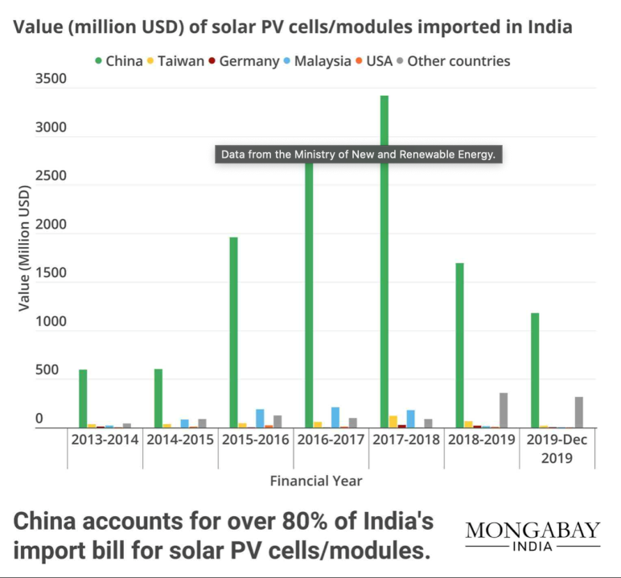

**10.**

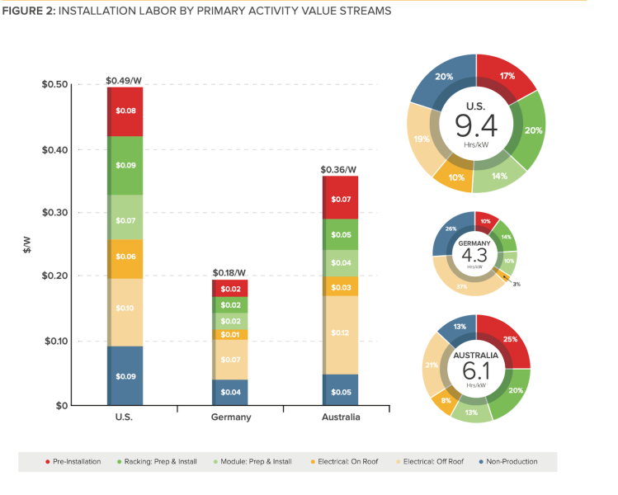

**11.**

|  |  |  |
| --- | --- | --- |
|  | **Utility scale** | **Distribution** |
| Relative cost per kW | Comparatively lower per kW installation cost and decr. as scale incr. | Comparatively higher |
|  | greater line loss over longer lines | line losses are negligible |
|  | Permitting costs and the costs of impact mitigation can be substantial at the beginning | few or no permitting costs in most communities. |
|  | located immediately adjacent to existing transmission lines and substations | located at the site of use and ability to place energy directly onto the local network |

|  |  |  |
| --- | --- | --- |
| Electricity Transmission Costs | A Grid Connection in itself leads to additional costs for solar farms along with the potential costs of new transmission leaders. | Distributed solar can almost always use existing transmission infrastructure at little or no cost. |
| Grid Stability | Large solar farms supply 100% of their outputs to the existing grid at discrete points that are often remote from use areas and which may also physically compete with existing large electrical point-sources. This makes managing the existing grid more difficult when solar penetration increases. | Much of Distributed Solar is consumed locally, at or near the point of generation, and those generation points can be theoretically spread across the area where it would be used. This results in even distribution and high grid stability, with decreased instances of accidental or rolling blackouts and brownouts. |
| Planning & Permitting Issues | Issues include Zoning and General Plan provisions for large-scale industrial and utility-type uses on lands usually reserved for agriculture and/or open space/wildlife habitat.   Provisions can be made to either mitigate the impacts to loss of agriculture or place a finite lifetime on the solar project, after which it must be removed and the land restored.  typically require use permits and environmental analysis before construction can commence.  The size and intensity of the use dictates to permitting jurisdictions that the operator should prepare a site restoration plan in anticipation of possible abandonment, along with financial assurance bonds to guarantee that there would be no public cost associated with site restoration. | Very few planning and permitting issues exist for distributed solar energy installations. |
| Space Requirements-limitations and opportunities |  |  |
| Environmental Issues | The potential loss of open space, agricultural land and biological habitat are usually cited as the main concerns with large scale solar development.  Solar Farms can be built on disturbed land like in Germany where they have been built on former airbases | The effect of adding additional development in the form of solar panels on parking lots, rooftops and other developed areas is minimal and often results in no impact. |
| Market for Solar |  |  |

**12.**Comparision Analysis of TATA Nexon ICE & TATA Nexon ICEV at 50% penetration of EVs in INDIA.

|  |  |  |
| --- | --- | --- |
|  | Tata Nexon ICE(150g/km) | Tata Nexon EV |
| Ex showroom price | 902000 | 1,450,000 |
| CO2(g/km) | 375000 | - |
| NOx(2%) | 18040 | - |
| Weight(1%) | 9020 | - |
| Scrapping fee(0.5%) | 4510 | 4510 |
| GST(25%) | 225050 | 72500 |
| Retail price | 1533620 | 1,527,010 |